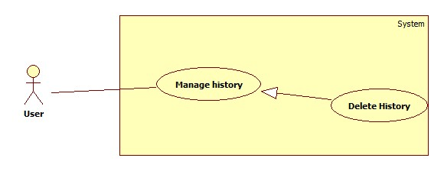

|  |  |  |  |
| --- | --- | --- | --- |
| **USE CASE –** | | | |
| **Use Case No.** |  | **Use Case Version** | 1.0 |
| **Use Case Name** | Delete history | | |
| **Author** | Mai Van Tan | | |
| **Date** | 15/01/2014 | **Priority** | Normal |
| **Actor:** User  **Summary:**   * User uses this case to delete search history.   **Goal:**   * Allow user deletes their search history.   **Triggers:**   * **User want to delete history of search result** * User clicks on the delete item of the history item.   **Preconditions:**   * User must login.   **Post Conditions:**   * **Success**: The history is deleted from history list. * **Fail:** Show the error to user.   **Main Success Scenario:**   |  |  |  | | --- | --- | --- | | Step | Actor Action | System Response | | 1 | User clicks on view history item. | System will show the list search history to screen. | | 2 | User clicks on delete item of history item. | System delete history and show the message “Xóa thành công” then refresh the list history. |   **Alternative Scenario:** N/A  **Exceptions:**   |  |  |  | | --- | --- | --- | | No | Actor Action | System Response | | 1 | Cannot delete history. | Show message: “Xóa không thành công”. |   **Relationships: N/A**  **Business Rules: N/A** | | | |
|  | | | |